Document/Website | Info | Offers | Audience
Microsoft Privacy Statement | Collection, Purpose and Usage of Personal Data | All Microsoft offers including services, applications, websites, software, servers, devices | Everyone - end customers or companies
Online Services Terms (OST) | Licensing Terms (legal agreement) - usage rights about Azure services. What can be done and what is forbidden. | Microsoft Online Services like Azure, Microsoft 365 services, Bing Maps, etc. | Organizations - legal teams
Data Protection Addendum | Appending to OST describing obligations by both parties (Microsoft and you) with regards to the processing of customer and personal data | Microsoft Online Services like Azure, Microsoft 365 services, Bing Maps, etc. | Organizations - legal teams, security teams
Trust Center | One stop shop web portal for everything related to security, compliance, privacy, policies, best practices, etc. | Microsoft Online Services like Azure, Microsoft 365 services, Bing Maps, etc. | Organizations - legal teams, security teams, business managers, administrators
Azure Compliance Documentation | Web portal focusing on compliance offerings in Azure, simmilar to the trust center but narrowed down | Azure | Organizations - legal teams, security teams, business managers, Azure administrators

Azure Sovereign Regions
Azure Sovereign Regions provide Azure services in markets with very strict regulatory requirements
- Azure Government designed for the US government
  - Separate instance of Azure (lifecycle, services, portal, etc.)
  - Physically isolated from other Azure regions
  - Only autorized scanned personel can get access
- Azure China designed for the Chinese market
  - Separate instance of Azure (lifecycle, services, portal, etc.)
  - Physically isolated from other Azure regions
  - Operated by a Chinese telecom company called 21Vianet
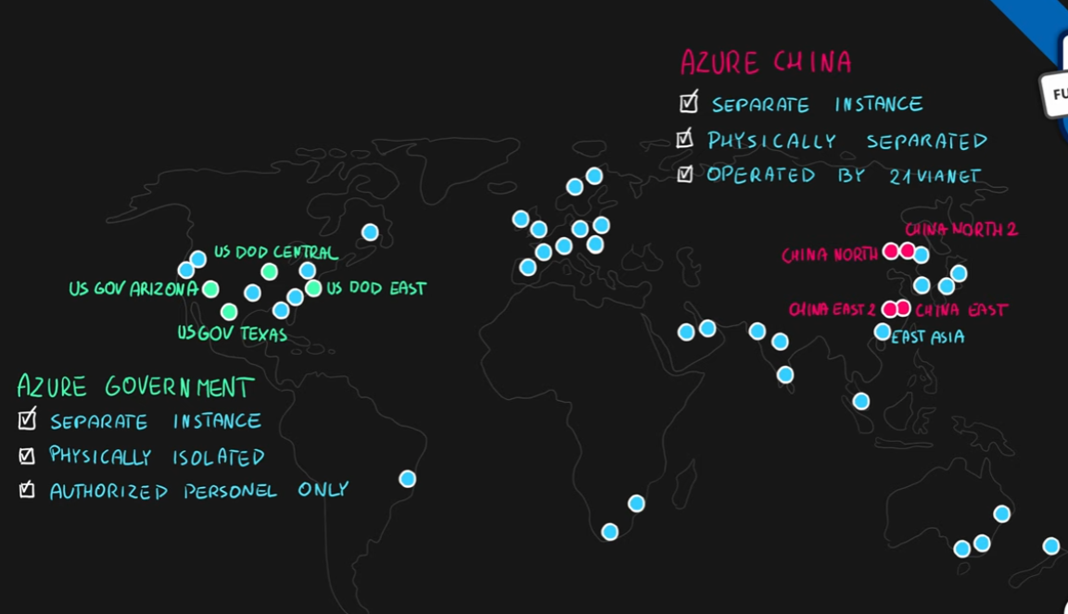

Summary
